**Dundee Primary School**

**School Improvement Report**

**Session 2017-2018**

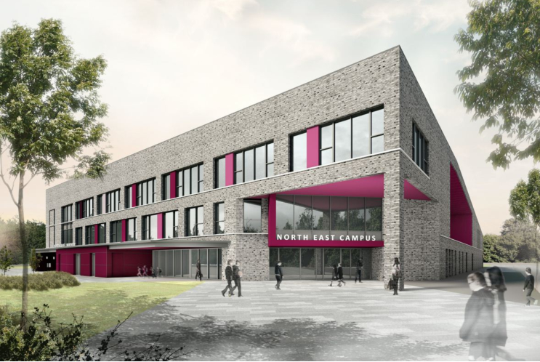

(Photo / Logo)

Longhaugh Primary School

Lothian Crescent

Dundee. DD4 0SX

Tel 438540

Email: [longhaughps@dundeecity.gov.uk](mailto:longhaughps@dundeecity.gov.uk)

This document shares and celebrates the improvements in our School and embraces all ages and stages. It is based upon our School Improvement Plan for session 2017 - 2018

|  |
| --- |
| **Our School Aims:** |

|  |  |  |  |  |  |  |  |  |  |  |  |  |  |  |  |  |  |  |  |  |  |  |  |  |  |  |  |  |  |  |  |  |  |  |  |  |  |  |  |  |  |  |  |  |  |  |  |  |  |  |  |  |  |  |  |  |  |  |  |  |  |  |  |  |  |
| --- | --- | --- | --- | --- | --- | --- | --- | --- | --- | --- | --- | --- | --- | --- | --- | --- | --- | --- | --- | --- | --- | --- | --- | --- | --- | --- | --- | --- | --- | --- | --- | --- | --- | --- | --- | --- | --- | --- | --- | --- | --- | --- | --- | --- | --- | --- | --- | --- | --- | --- | --- | --- | --- | --- | --- | --- | --- | --- | --- | --- | --- | --- | --- | --- | --- |
| **Our School’s Context:**  **Attainment Information**   |  |  |  |  |  |  |  |  |  |  |  |  |  | | --- | --- | --- | --- | --- | --- | --- | --- | --- | --- | --- | --- | --- | |  | **Year 1** | | | | **Year 4** | | | | **Year 7** | | | | |  | **R** | **W** | **L&T** | **N** | **R** | **W** | **L&T** | **N** | **R** | **W** | **L&T** | **N** | | **2015/16** | **81%** | **83%** | **69%** | **93%** | **56%** | **33%** | **58%** | **44%** | **78%** | **81%** | **83%** | **79%** | | **2016/17** | **81%** | **81%** | **78%** | **89%** | **69%** | **69%** | **86%** | **89%** | **54%** | **51%** | **66%** | **57%** | | **2017/18** | **73%** | **60%** | **60%** | **80%** | **82%** | **56%** | **88%** | **76%** | **71%** | **67%** | **86%** | **79%** | |

|  |
| --- |
| **Continuous Professional Development:**  Over the past year, our staff members have undertaken a wide range of training and development activities, including:   * Moderation activities led by our school QAMSO * Consolidation of Conceptual Understanding in Numeracy * Developing mathematical thinking * Numicon to support learning in Numeracy & Mathematics * Jo Boaler learning materials * A range of literacy training including RWI spelling, vocabulary & comprehension * Big Writing * Developing pedagogical approaches with a focus on high quality learning & teaching ‘Every Lesson Counts’ * A wide range of professional reading materials with a focus on closing the gap * Digital technologies training to enhance learners’ experiences * Nurturing approaches – all core modules * Some staff have participated in masters level study |

**Review of Improvement Progress for Session 2017-2018**

|  |
| --- |
| **School Improvement Priority 1: Literacy Development** |
| **Progress and Impact:**   * **Development of a staged approach to Literacy with a focus on early intervention and prevention (see Appendix). Staff consult flowchart when addressing barriers to learning in Literacy** * **Staff describe how they are more confident at early identification of barriers to learning** * **Almost all pupils are accessing Literacy curriculum across all levels and are actively engaged in their learning. A wide range of resources are used to support this area of the curriculum making reference to our staged approach.** * **There has been a strong focus on equity for all learners with support targeted effectively through data and teacher judgements and observations** * **Our priority to improve attainment in Literacy at all levels has not been achieved, however evidence of improvement can be seen at P4 & P7 stages particularly in reading and listening & talking** * **Support staff are taking on reading teaching roles and have been key in supporting learners across all stages** * **There has been real emphasis on high quality learning & teaching** |
| **Next Steps:**   * **Continue to focus on high quality learning & teaching. Develop our own learning & teaching manual incorporating different pedagogical approaches** * **Develop pedagogy team to support delivery of high quality learning experiences** * **Develop our approaches to moderation based on the moderation cycle** * **Develop our own progression pathways** * **Develop analysis of learner engagement using Leuven’s scale** * **Develop our use of standardised assessment data to inform next steps in learning** |

|  |
| --- |
| **School Improvement Priority 2: Numeracy Development** |
| **Progress and Impact:**   * **Development of a staged approach to Numeracy with a focus on early intervention and prevention (see Appendix). Staff consult flowchart when addressing barriers to learning in Literacy** * **Staff describe how they are more confident at early identification of barriers to learning** * **Almost all pupils are accessing Numeracy curriculum across all levels and are actively engaged in their learning. A wide range of resources are used to support this area of the curriculum making reference to our staged approach** * **Almost all staff are trained in CUIN and have attended follow up sessions throughout the year, led by our Numeracy pioneer** * **Number talks has been a development focus with support from our Dundee City Council Numeracy staff tutors** * **There has been a strong focus on equity for all learners with support targeted effectively through data and teacher judgements and observations** * **Our priority to improve attainment in Numeracy at all levels has not been achieved, however evidence of improvement can be seen at P7 & moderation processes have improved** * **There has been real emphasis on high quality learning & teaching** * **Working groups have developed a lesson coaching model with creation of new templates for recording feedback** |
| **Next Steps:**   * **Continue to focus on high quality learning & teaching. Develop our own learning & teaching manual incorporating different pedagogical approaches** * **Develop pedagogy team to support delivery of high quality learning experiences** * **Develop our approaches to moderation based on the moderation cycle** * **Develop our own progression pathways** * **Develop analysis of learner engagement using Leuven’s scale** * **Develop our use of standardised assessment data to inform next steps in learning** * **All staff to participate in Numicon training** |

|  |
| --- |
| **School Improvement Priority 3:**  **Develop & Implement a staged approach to Health & Wellbeing (Nurturing Approaches)& Implement a staged approach to Health & Wellbeing (Nurturing Approach)** |
| **Progress and Impact:**   * **New database created to improve record keeping** * **Staff more confident at creating Able plans with many strategies now becoming part of universal provision and fewer Able plans created** * **New referral system & flowchart in place for early support in HWB (Nurture)** * **Almost all staff participated in core module nurture training** |
| **Next Steps:**   * **Implementation of new referral system** * **Create menu of nurture support** * **CLP Paul Dix – When the adults change** * **Deepen staff understanding of HWB responsibility of all** * **Develop a framework to ensure progression in learning** |

**Our Improvement Priorities for Session 2018-2019**

|  |
| --- |
| **Raise attainment in Numeracy through developing staff understanding of progression within the Es and Os**  **Continue to develop our learning & teaching approaches with a focus on high quality** |
| **Raise attainment in Literacy through developing staff understanding of progression within the Es and Os**  **Continue to develop our learning & teaching approaches with a focus on high quality** |
| **Improve outcomes in HWB through developing staff understanding of progression within the Es and Os** |
| **Develop our approaches to assessment & moderation** |
| **Develop parental engagement in learning** |

Please visit [www.careinspectorate.com](http://www.careinspectorate.com) or <https://education.gov.scot/what-we-do/inspection-and-review/reports> for Care Inspectorate or HMIE Inspection Reports.

**Further Information can be found at:**

|  |  |  |  |
| --- | --- | --- | --- |
|  |  |  | [Image result for additional support needs](https://www.google.co.uk/imgres?imgurl=http://www.roevalleyintegrated.co.uk/cmsfiles/items/pageimages/308.5_auto/sen_1.gif&imgrefurl=http://www.roevalleyintegrated.co.uk/curriculum-and-assessment/additional-needs/&docid=oU3qQprNpIx0TM&tbnid=Le4edm8pi6vWGM:&vet=10ahUKEwjk5syCwNnWAhWoCMAKHbSnAP8QMwg1KBAwEA..i&w=308&h=140&hl=en&safe=strict&bih=697&biw=1004&q=additional%20support%20needs&ved=0ahUKEwjk5syCwNnWAhWoCMAKHbSnAP8QMwg1KBAwEA&iact=mrc&uact=8)  Dundee Education Plan  <https://www.dundeecity.gov.uk/sites/default/files/publications/annual_education_plan_2017-18.pdf> |
| National Improvement Framework  <http://www.gov.scot/Publications/2016/01/8314> | HGIOS 4 Self-evaluation <https://education.gov.scot/improvement/Documents/Frameworks_SelfEvaluation/FRWK2_NIHeditHGIOS/FRWK2_HGIOS4.pdf> | Tayside Plan C&FS  [External Link](http://dmlink.dundeecity.gov.uk/WebRep/CeRDMSGetNodeContent/OTgetNode.php?node=a6969ea7679c6ca7a609)   ' Tayside_Plan 1a.pdf' |  |

|  |  |  |  |
| --- | --- | --- | --- |
|  |  |  |  |