Dundee Primary School

School Improvement Report
Session 2017-2018
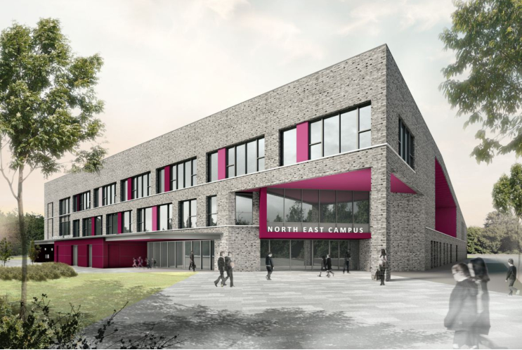

(Photo / Logo)

Longhaugh Primary School
Lothian Crescent
Dundee. DD4 0SX
Tel 438540
Email: longhaughps@dundeecity.gov.uk

This document shares and celebrates the improvements in our School and embraces all ages and stages. It is based upon our School Improvement Plan for session 2017 - 2018

Our School Aims:

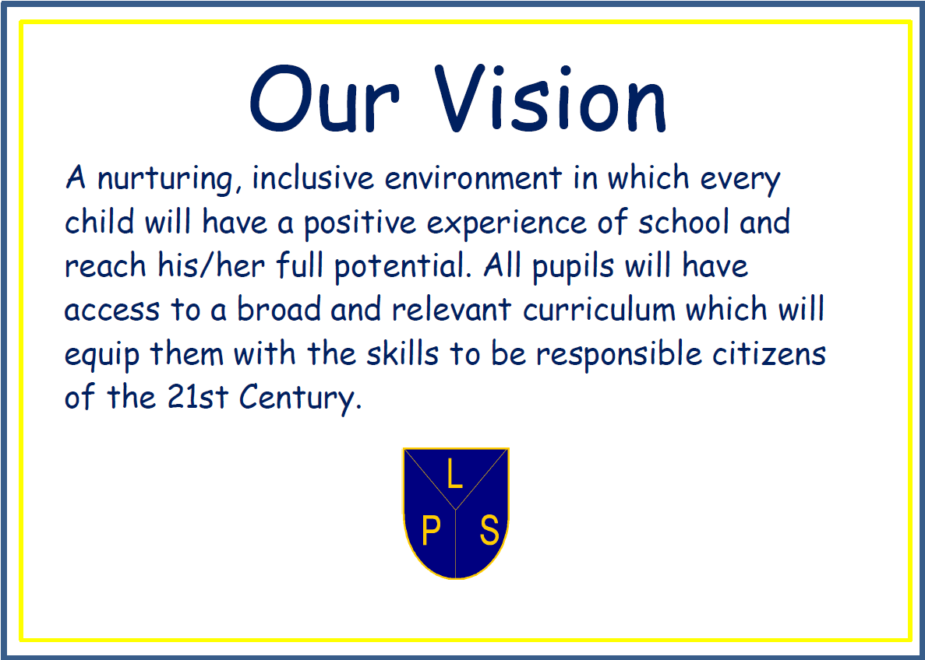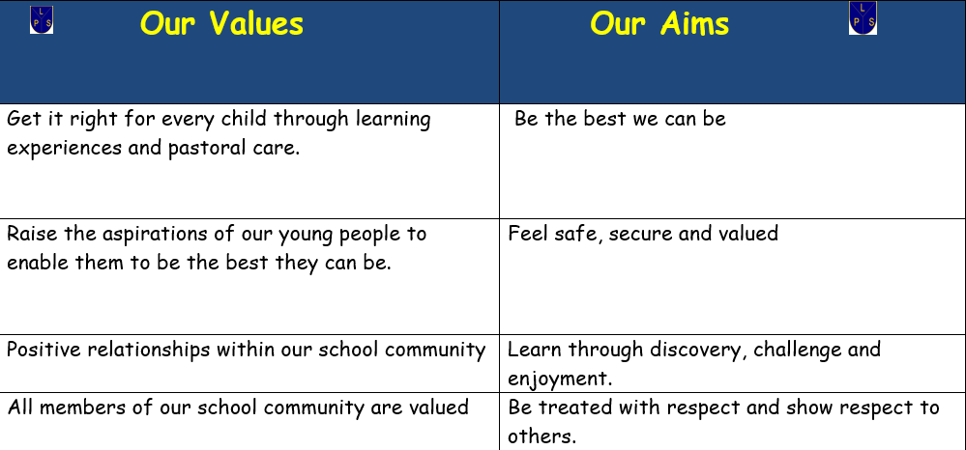

Our School’s Context:

Attainment Information
 | Year 1 |  |  |  | Year 4 |  |  |  | Year 7
 | R | W | L&T | N | R | W | L&T | N | R | W | L&T | N
2015/16 | 81% | 83% | 69% | 93% | 56% | 33% | 58% | 44% | 78% | 81% | 83% | 79%
2016/17 | 81% | 81% | 78% | 89% | 69% | 69% | 86% | 89% | 54% | 51% | 66% | 57%
2017/18 | 73% | 60% | 60% | 80% | 82% | 56% | 88% | 76% | 71% | 67% | 86% | 79%

Continuous Professional Development:
Over the past year, our staff members have undertaken a wide range of training and development activities, including:
- Moderation activities led by our school QAMSO
- Consolidation of Conceptual Understanding in Numeracy
- Developing mathematical thinking
- Numicon to support learning in Numeracy & Mathematics
- Jo Boaler learning materials
- A range of literacy training including RWI spelling, vocabulary & comprehension
- Big Writing
- Developing pedagogical approaches with a focus on high quality learning & teaching ‘Every Lesson Counts’
- A wide range of professional reading materials with a focus on closing the gap
- Digital technologies training to enhance learners’ experiences
- Nurturing approaches – all core modules
- Some staff have participated in masters level study

Review of Improvement Progress for Session 2017-2018

School Improvement Priority 1: Literacy Development

Progress and Impact:

- Development of a staged approach to Literacy with a focus on early intervention and prevention (see Appendix). Staff consult flowchart when addressing barriers to learning in Literacy
- Staff describe how they are more confident at early identification of barriers to learning
- Almost all pupils are accessing Literacy curriculum across all levels and are actively engaged in their learning. A wide range of resources are used to support this area of the curriculum making reference to our staged approach.
- There has been a strong focus on equity for all learners with support targeted effectively through data and teacher judgements and observations
- Our priority to improve attainment in Literacy at all levels has not been achieved, however evidence of improvement can be seen at P4 & P7 stages particularly in reading and listening & talking
- Support staff are taking on reading teaching roles and have been key in supporting learners across all stages
- There has been real emphasis on high quality learning & teaching

Next Steps:
- Continue to focus on high quality learning & teaching. Develop our own learning & teaching manual incorporating different pedagogical approaches
- Develop pedagogy team to support delivery of high quality learning experiences
- Develop our approaches to moderation based on the moderation cycle
- Develop our own progression pathways
- Develop analysis of learner engagement using Leuven’s scale
- Develop our use of standardised assessment data to inform next steps in learning

School Improvement Priority 2: Numeracy Development

Progress and Impact:
- Development of a staged approach to Numeracy with a focus on early intervention and prevention (see Appendix). Staff consult flowchart when addressing barriers to learning in Literacy
- Staff describe how they are more confident at early identification of barriers to learning
- Almost all pupils are accessing Numeracy curriculum across all levels and are actively engaged in their learning. A wide range of resources are used to support this area of the curriculum making reference to our staged approach
- Almost all staff are trained in CUIN and have attended follow up sessions throughout the year, led by our Numeracy pioneer
- Number talks has been a development focus with support from our Dundee City Council Numeracy staff tutors
- There has been a strong focus on equity for all learners with support targeted effectively through data and teacher judgements and observations
- Our priority to improve attainment in Numeracy at all levels has not been achieved, however evidence of improvement can be seen at P7 & moderation processes have improved
- There has been real emphasis on high quality learning & teaching
- Working groups have developed a lesson coaching model with creation of new templates for recording feedback

Next Steps:

- Continue to focus on high quality learning & teaching. Develop our own learning & teaching manual incorporating different pedagogical approaches
- Develop pedagogy team to support delivery of high quality learning experiences
- Develop our approaches to moderation based on the moderation cycle
- Develop our own progression pathways
- Develop analysis of learner engagement using Leuven’s scale
- Develop our use of standardised assessment data to inform next steps in learning
- All staff to participate in Numicon training

School Improvement Priority 3:

Develop & Implement a staged approach to Health & Wellbeing (Nurturing Approaches)& Implement a staged approach to Health & Wellbeing (Nurturing Approach)

Progress and Impact:

- New database created to improve record keeping
- Staff more confident at creating Able plans with many strategies now becoming part of universal provision and fewer Able plans created
- New referral system & flowchart in place for early support in HWB (Nurture)
- Almost all staff participated in core module nurture training

Next Steps:

- Implementation of new referral system
- Create menu of nurture support
- CLP Paul Dix – When the adults change
- Deepen staff understanding of HWB responsibility of all
- Develop a framework to ensure progression in learning

Our Improvement Priorities for Session 2018-2019

Raise attainment in Numeracy through developing staff understanding of progression within the Es and Os
Continue to develop our learning & teaching approaches with a focus on high quality
Raise attainment in Literacy through developing staff understanding of progression within the Es and Os
Continue to develop our learning & teaching approaches with a focus on high quality

Improve outcomes in HWB through developing staff understanding of progression within the Es and Os

Develop our approaches to assessment & moderation

Develop parental engagement in learning

Please visit www.careinspectorate.com or https://education.gov.scot/what-we-do/inspection-and-review/reports for Care Inspectorate or HMIE Inspection Reports.

Further Information can be found at:

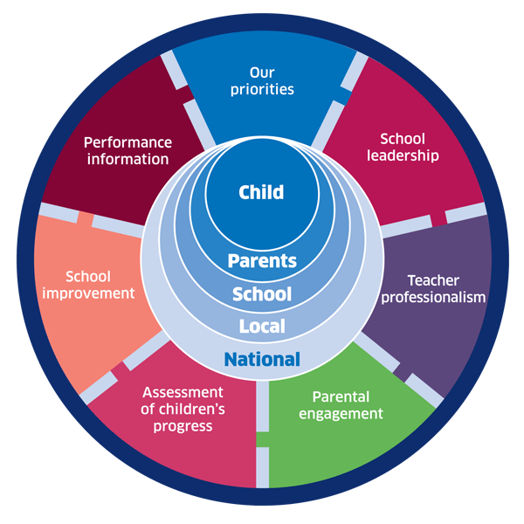 | 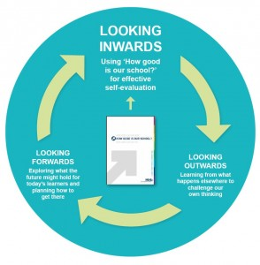 |  |   Dundee Education Plan  https://www.dundeecity.gov.uk/sites/default/files/publications/annual_education_plan_2017-18.pdf
National Improvement Framework  http://www.gov.scot/Publications/2016/01/8314 | HGIOS 4 Self-evaluation https://education.gov.scot/improvement/Documents/Frameworks_SelfEvaluation/FRWK2_NIHeditHGIOS/FRWK2_HGIOS4.pdf | Tayside Plan C&FS  External Link ' Tayside_Plan 1a.pdf'

