School/Educational Setting Improvement Plan 2022-2023

Establishment: Longhaugh Primary School

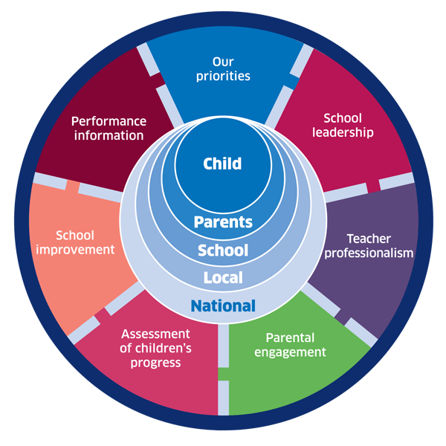 |   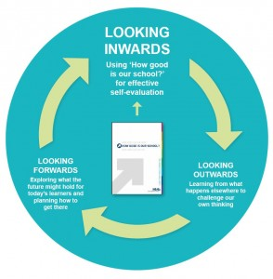 |  | CFS Service Plan  External Link '170-2021 Children and Families Service Plan 2021-24.doc'
National Improvement Framework  http://www.gov.scot/Publications/2016/01/8314 | HGIOS 4 Self-evaluation https://education.gov.scot/improvement/Documents/Frameworks_SelfEvaluation/FRWK2_NIHeditHGIOS/FRWK2_HGIOS4.pdf | Tayside Plan CFS  New plan to follow | Every Dundee Learner Matters Strategy Paper  External Link '20210419 Dundee strategy FINAL VERSION.docx'

The aims of the School/Educational Setting are aligned to and informed by the National Improvement Framework Priorities, the C&FS Service Plan, ’Every Dundee Learner Matters’ strategy and the Tayside Plan for Children, Young People and Families. They are further informed by self-evaluation and associated toolkits.

This Plan will be implemented via a cycle of planned activities including consultation with pupils and parents and liaison with partners to evaluate the impact of improvement activities. The Plan links directly to self-evaluation toolkit information.
External Link 'DundeeGuide May 2021.pdf'

NIF Priorities:
- Improvement in attainment, particularly in literacy and numeracy;
- Closing the attainment gap between the most and least disadvantaged children;
- Improvement in children and young people’s health and wellbeing, and;
- Improvement in employability skills and sustained, positive School / Educational Setting leaver destinations for all young people
NIF Drivers:
- School / Educational Setting Leadership
- Teacher Professionalism
- Parental Engagement
- Assessment of Children’s Progress
- School / Educational Setting Improvement
- Performance Information
Tayside Vision for Children, Young People and Families

“Our children and young people will have the best start in life and Tayside will be the best place in Scotland to grow up.”

Dundee Vision for Children, Young People and Families
“Our children and young people will have the best start in life and Tayside will be the best place in Scotland to grow up.”

and

“Every Dundee Learner Matters”

In order to provide a clearly defined improvement focus for individual children and young people, ‘Every Dundee Learner Matters’ focuses on ‘Three Ps”:

- Presence – ensuring that all pupils attend regularly and promptly
- Participation – creating a climate within schools where all pupils feel welcome and valued; and
- Progress – developing policies and practices that maximise the achievement and ambitions of all pupils.
Tayside’s Five Priorities for Children, Young People and Families

- Our children will have the best start in life; they will be cared for and supported to live in nurturing environments.
- Our children, young people, and their families will be meaningfully engaged with learning, and combined with high quality learning experiences, all children and young people will extend their potential.
- Our children and young people will be physically and mentally and emotionally healthy.
- Our children and young people who experience inequalities and disadvantage will achieve health, wellbeing and educational outcomes comparable with all other children and young people.
- Our children and young people will feel safe and protected from harm at home, school and in the community.

School/Setting Vision, Values, Aims: Vision under review.
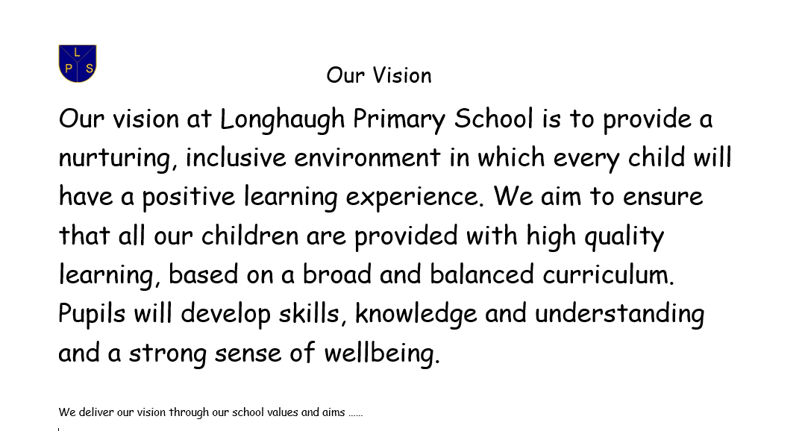
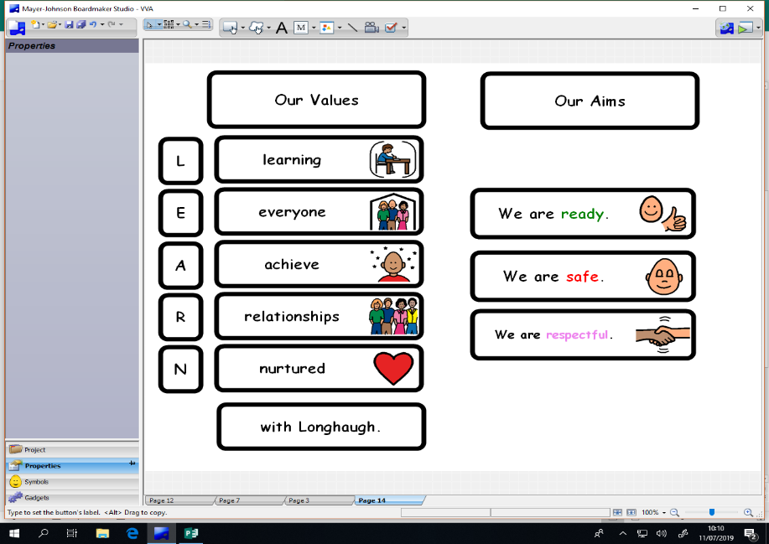

Consultation and Collaborative Self-Evaluation Processes

This Plan has been discussed with stakeholders and has been continued and updated from last session as we journey through our recovery period. Some of the processes we have used are as follows:
- On-line Meetings
- Questionnaires / Feedback
- Self-evaluation activity
- Microsoft Sway information tools

Tools for Measurement of Progress:

Self-Evaluation - assessment of current position (inwards, outwards, forwards - HGIOS 4, HGIOEL&C)

Evidence from:
- Teacher Professional Judgement/ACEL levels
- Standardised Assessment Data/Pitfalls/SQA data/trends (Insight)/ BGE Toolkit / Benchmarking/Moderation
- Exclusions and Attendance Data
- Changing Trends and Profiles in any of the above data
- Feedback from parents, children and young people and staff (evidenced through HMI questionnaires or other survey apps)
- Pupil learning plans, achievement and learning conversations
- Collaborative Action Research
- Interventions for Equity
- Model for Improvement activities
- Profile of outcomes for targeted groups: LAC; Young Carers; SIMD 1 and 2; FSM
- Dundee School Improvement Framework
- Inspection Findings – external scrutiny
- LA scrutiny – e.g. Extended review

2022-2023 RAISING ATTAINMENT & IMPROVING OUTCOMES FOR CHILDREN, YOUNG PEOPLE AND FAMILIES IN DUNDEE

As we ‘Build Back Better’ through our recovery period we must continue to raise attainment and close the outcome gaps that exist across our School/Educational Settings at pace, and with a sense of urgency.

This is the core business of all Dundee School/Educational Settings and establishments. There is, therefore, no such thing in Dundee as a ‘non-attainment challenge School/Educational Setting’. Our strategy for Dundee is to ensure that ‘Every Dundee Learner Matters’.

All School/Educational Setting Improvement Plans will include the Key Aims / Expectations / Actions outlined within the plan on the following pages. Whilst all establishments should feel free to add additional aims and actions specific to their own setting as required, all improvement activity should be designed to improve outcomes for all learners and close identified outcome gaps based on our core strategy for the city.

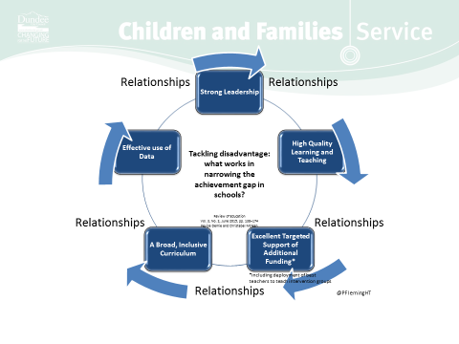

Dundee City Council  Children and Families Service | IMPROVEMENT PRIORITY 1: LEADERSHIP and MANAGEMENT  Completed actions have been highlighted. These are linked to previous school improvement report.
Aims  (what are we going to achieve?) | HGIOEL&C  HGIOS4  QIs | Expectations | Actions  (What will we do?) | Measurement  (how will we know we are making a difference?) | Progress / Impact  (what has improved?)  BRAG – December, March, & May | Timescale / Responsibility
Revise Values and Aims in line with DCC aspiration/ambition to raise attainment, incorporating the vision and rationale from ‘Every Dundee Learner Matters’ (EDLM) | 1.3 | - The Vision, Values and Aims of all School/Educational Settings must promote a positive image of the child, ambition, aspiration, expectations, challenge and a focus on children first (constant message from Dundee School Inspections – our children are capable of much more)  - All practice across the school/ setting directly links to Vision, Values & Aims and is regularly re-visited.  - VVA conversations involve all stakeholders – pupils, families, staff, partners, community  - There is a consistent approach to relationships and restorative practice across the setting to promote presence and participation of all learners.  The guiding vision within Every Dundee Learner Matters creates a high performing system that ensures the progress of all children and young people, particularly those who are a cause for concern. | - Promote our recently revised vision, values and aims within our school, community and beyond.  - Continue to embed our VVA into learning & teaching, encouraging our pupils to give their best version within all learning episodes.  - Link all improvement activities to our VVA, making this explicitly clear in SIP change ideas.  - Link VVA & Relationships policy with RRS approach.  - Produce an abbreviated version of our expectations (SWAY) for all stakeholders.  - Celebrate our VVA successes at whole school assemblies and as part of our wider achievement and attainment.  Improve our perceptions data to gather evidence of this from all stakeholders.  - All staff to receive training and awareness sessions on Trauma Informed Practice, in line with DCC implementation plan for trauma informed workforce. Develop a school action plan. (link action plan).  All staff to be supported with appropriate training to meet the needs of all our children e.g. scripting and timely interventions to ensure consistency of approach. Zones of regulation.  - Training and learning conversations will be used to moderate progress and share practice across our school.  - Able refresher training to be delivered to all staff. | All stakeholders will be able to talk about the schools VVA and how they can impact on pupil learning and wellbeing.  The VVA will be strong and well established and relevant to all learners.  VVA will have a high profile within our school and throughout learning episodes.  Survey pupils/parents  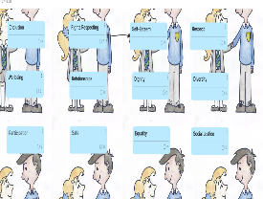  Strategies, language, and actions used by all staff are consistent when supporting our children. e.g restorative conversations, co-regulation, fix it folders, scripting.  Every class has a whole class able plan to ensure a strong universal provision across the school. This should reduce the number of individual plans.  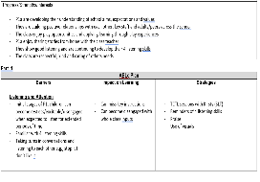  . | The VVA are displayed and referred to in all classrooms. There is a shared used of language which reflects our values and aims.  Staff have aligned wee HGIOS indicators with school values and introduced a termly calendar. This will be implemented in January 2023.  VVA are available on all email correspondence, Seesaw. etc  Vision statement to be condensed as although appropriate feedback would suggest no one can recall our vision statement. Survey of stakeholders to finalise vision statement produced following result:  Together we ensure every learner matters equally.  Together we aim to provide a high quality, inclusive learning experience.  Together we promote lifelong learning opportunities for all.  Together we build strong, positive, and lasting relationships.  Together we show kindness.  Relationships policy now available as a SWAY. Parents sent link via Seesaw.  No negative feedback received.  Learning targets now included in individual ABLe plans where learners making limited progress. (see individual plans). | December 2022  Curriculum leads.  June 2023  Ongoing throughout session  DHT/PT Supporting learners.
Implement planned robust self-evaluation procedures in relation to learning and teaching involving all stakeholders | 1.1  (2.3) | - All educators must have a clear understanding of the purpose of self-evaluation for improvement.  - There is a culture of reflective practice and responsive, continuous improvement, using evaluative language  - All educators understand their role in the self- evaluation process and subsequent impact on children’s progress.  - Educators have a clear understanding of the link with CLPL and improved outcomes for learners.  - An Annual Quality Assurance calendar is in place and is followed rigorously.  - Classroom visits and observations focus on the quality of learning and teaching within a high quality learning provision.  - There are planned opportunities for sharing practice and for collaboration within and across schools, settings and networks supported by SIGs and the SIPs.  - Detailed tracking and monitoring are in place throughout BGE.  - Planned, regular and rigorous discussions of tracking data and pupil progress take place at SLT / departmental / class teacher / educator levels  - Self-evaluation and CLPL activities result in agreed actions and interventions which are recorded and followed up as appropriate – supported by the SIG. | - Ensure all stakeholders have an input and understanding of whole school self-evaluation for self-improvement.  - Continue to develop robust approaches to self-evaluation and ensure all staff are committed to engaging with SE activity, embedding SE activity into our culture.  - Draw on a range of data to unform next steps in learning, closing identified gaps and planning for improvement.  - Support will be sought from LA staff/EO to achieve intended impact and progress within our SE processes.  - Work closely with attainment advisor to intersect our data and know our impact.  - Ensure all CLPL is carefully weaved and linked with our priorities within this plan (SIG groups)  - Our approaches to QA will include an intense focus for this session, ensuring we make very good progress and maintain high standards for all learners.  - Staff will engage with our self and peer reflection plan using video recording to improve the quality of learning & teaching and the learners.  - Staff will continue to work within learning teams to improve practice led by teaching colleagues, using the refreshed standards as guidance.  - Staff will regularly reflect on our own standards and evaluate themselves against our own expectations.  - All staff to engage with school improvement planning to prioritise key areas of improvement throughout the year.  - Key priority areas to be broken down into individual improvement priorities using the EDLM strategy approach.  - Continue to track and monitor our children across the BGE using the tracking progress documents. | Good uptake in our Self Evaluation inputs and surveys – staff can articulate areas for improvement.  Whole staff team can articulate key areas for improvement, where we are on the journey and their role/responsibility in making a difference.  Similar strategy for children to be involved in school improvement and their role.  Longhaugh Standards will provide consistent approach to learning, teaching, and assessment across Longhaugh.  Consistency of high-quality learning and teaching  -Increased engagement and participation in lessons  Pupil voice – reporting positively about experiences within the classroom.  CLPL plan, PRD actions and professional learning across the school providing staff with opportunities to develop, lead and have responsibility for school improvement, impacting on improved outcomes for our learners.  Quality assurance procedures result in improvements to learning and teaching and progress in attainment and achievement.  All staff are part of a school improvement group. This session they have engaged with inquiry projects.  Still predominantly in Literacy & Numeracy. This must be used better to track progress and achievement.  Introduction of tracking wider achievements in place and identifying where pupils should be targeted for extra curricular. | Next sessions raising attainment plan to be available as a postcard for parents, carers, and all stakeholders. This will be displayed on Seesaw and feedback on the plan will be sought during parent contact evenings.  Parents reported they enjoy more informal chats than formal parent events such as parent council.  Introduce catch up chats.  Self-evaluation schedule to be fully adhered to but should include opportunities for all staff to be involved. This will provide teaching staff opportunities to engage with other colleagues to access a greater idea pull and add depth to the evaluative and reflective comments being made. This is an area identified by DHT LSG as an area for improvement.  QA assurance calendar being used to ensure consistency of approach and to monitor high quality learning & teaching. Revisiting of PSV recording. Identified use of 2.3 rubric. (Shared observations.)  QA assurance environment checklist being used to ensure non negotiables are in place. Revisiting of PSVs include environment checklist. Support provided by LSG.  Included in collegiate calendar. Protected time as part of staff meeting 1.5 hours.  See impact posters.  Develop our trackers to provide more robust information on learners progress. | Ongoing throughout the session  Ongoing throughout the session
Increase/improve opportunities for listening and responding to children’s/learners’ voice/leadership of learning. |  | - The guiding principle of listening and responding to children is embedded and included in the QI Calendar  - All schools use ‘wee HGIOS’ to embed learner voice and leadership  - Communication/engagement with parents is tracked and monitored through levels of participation across the school  - Motivation of young people is promoted – assemblies, PSE lessons etc.  - Learner Voice – there is regular feedback from learners re quality of learning provision  - Young people lead learning  - Young people are involved in school self-evaluation e.g. taking part in observations and self-evaluation discussions | - Children to lead aspects of improvement planning (linked with HGIOS 4) and Learning Council to have a clear role in school improvement.  - SLT moderation process will include dialogue with pupils (see QA information)  - Develop our approaches to class council. | Data from: -  •Pupil focus groups  •Pupil Council  •Learning Council  •Pupil surveys  Learners Conversations planned as part of PSV.  Develop’ spotlight children.’  Pupil Voice evident in all classes.  Class council tasks encourage all learners to participate.  Pupils will have high expectations of themselves and feel confident to participate in discussions around their school. | Wee HIGIOs being used to structure questions to obtain pupil views. The following data has been collected:  March 22- My Relationships  May22- Self Regulation  June 22- My Learning  Include feedback on relationships policy.  All classes participate in class council tasks at the end of assemblies to gather pupil voice in identified areas.  . Further assessment of need to be gathered using Zone of Regulation Learner Self-reflection tool. This will provide a baseline measure prior to the roll out of the intervention. The rationale for implementing this intervention is that it is a cost effective and accessible resource, which build on strategies currently used within LPS.. | Ongoing  Ongoing
Implement robust processes for use of data/analysis to monitor and track individual progress leading to improved outcomes | 2.3  (1.1) | - Regular and rigorous analysis of attendance data (focus on presence) and support for pupils to maintain good attendance takes place  - Children’s learning and progress are regularly analysed and evaluated using a wide range of sources  - Appropriate data is used to identify areas for improvement at all levels  - Engagement in benchmarking activity within and across schools / settings and authorities is a regular feature  - Improved understanding (across the school) of data and associated MIS systems to ensure effective use and clear links to tracking and reporting to parents  - Target setting by educators and pupils is embedded across the school/setting | - To ensure that all data is used more robustly and well supported with a robust moderation process.  - Clear focus on attendance from SFDW using outcomes form CAR model.  - Clear focus on attainment in literacy and numeracy using curriculum lead roles to support interventions and consistent focus on data analysis – see data dialogues.  - Data to be used more robustly by all staff to inform next steps for learning and teaching to ensure there is differentiation that meets the needs of learners- use of PANDA tool to support attainment discussions.  - Introduction of Glasgow model of wellbeing profiles.  - BGE tracking documents  - Planned collaboration events across Campus/cluster and SIP partnership to further engage with benchmarks to improve staff understanding.  - Robust Quality Assurance Calendar includes moderation of evidence of progress using a variety of sources at each planning block-jotters/assessment files/data  - Moderation activity included in QA calendar involving learning teams/campus and cluster  - Create opportunity to train staff on data analysis. – external input – data/attainment advisor?  - | Increase in attendance.  Engagement with SFDW  Writing progress and achievement increase .  Numeracy progress and achievement increase .  Children report that feel valued, safe and happy in school.  Staff will feel more confident in using their professional judgements, their assessment evidence and professional dialogue activities to understand their data and how to effectively use targeted approaches or support to address the gaps  Begin to see improvement in attainment or progress individuals and/or groups are making.  DHT supporting staff with data analysis.  Support available from DCC Simrit. | All absences are followed up, aiming for no TBCs.  Regular attendance meetings with families.  Staff engage very well with ‘data dialogues’  See whole school data profile.  Robust moderation processes in place. Staff engaging well with all moderation activity in learning teams and across campus. These are a feature in all INSET days. Included in collegiate calendar at start of school session.  Staff more confident at moderation and making more accurate judgements. All staff can provide evidence to back up judgements/  All staff make good use of benchmarks. | Termly – DHT/HT  Ongoing Reading Leader/Literacy 2nd level lead /DHT  Ongoing Numeracy Pioneer  Termly – DHT/HT  Termly  All staff

Dundee City Council  Children and Families Service | IMPROVEMENT PRIORITY 2: LEARNING PROVISION
Aims  (what are we going to achieve?) | HGIOEL&C  HGIOS4  QIs | Expectations | Actions  (what will we do?) | Measurement  (how will we know we are making a difference?) | Progress/Impact  (what has improved?)  BRAG – December, March, & May | Timescale / Responsibility
Ensure provision of high-quality learning and teaching and learner engagement and participation for all  (Feedback; differentiation; learners leading learning) | 2.3 | - A clear Learning and Teaching policy, followed by all educators, is in place and is in line with DCC Policy to promote a strong culture of high quality learning.  - The school/setting has a Standard for Learning, aligned with the Dundee Standard, taking cognisance of BTC, AifL, Birth to 6 (LTiD) and DYW.  - All educators regularly attend CLPL which supports reflective practice and improve pedagogical understanding, leading to improved outcomes for learners.  - Focus on leadership at all levels.  - HR support is engaged at an early stage when supporting staff attendance  - Underperformance is challenged early, consistently, and rigorously, using DNCT / GTCS / SSSC standards and procedures  - HR support is engaged at an early stage when challenging underperformance | - Review and refresh our Standard for Learning, Teaching & Assessment- engage with the teaching cycle to identify which parts need to be a focus. E.g differentiation, feedback  - Ensure our universal, additional, and targeted support is consistent, using ABLE /CARE plans here all stakeholders are involved.  - Revisit a range of pedagogical approaches to ensure all teachers are implementing them consistently to promote learner engagement e.g. coop learning, digital skills (EDLM)  - Develop pupil voice across all areas of learning .  To develop opportunities within SIP, staff learning teams and cluster to visit other colleagues to learn and share excellent practice (early stages)  - Develop our approaches using digital technologies to enhance teaching and learning experiences.  - Use of Leven Scale to measure levels of engagement within the classroom  - All classrooms implement the strategies and tools to support learning using the Good Practice Checklist – revisit this and ensure consistently embedded across school.  - Encourage and develop a culture of high expectations for all learners through sharing CLPL that supports our self-evaluation e.g Improve differentiation to meet all needs.  - Allow staff to lead elements of improvement across the school e.g. SIG, Numeracy, Writing, RRS, Wider Achievement, inquiry teams and curriculum lead roles across the school  - HR support and guidance sought when necessary and at an early stage. | Teacher Judgement  Learners’ conversations  Children are participating in mainstream or our enhanced provisions, consistency of support strategies to meet learning needs.  Pre and post surveys of staff  Self-evaluation of 2.3 using challenge questions.  PSV and peer observations  Improved Attainment  More engaged learners.  Feedback on PDSAs  Staff feedback on opportunities to lead and learn, focusing on improving outcomes for all.  Universal strategies of support consistent, non-negotiables in place across all learning environments.  Staff confidence and drive to support school improvement – evidence through professional discussions and impact on learning experiences for all, work within Inquiry groups to support SIP | Standards reviewed and refreshed.  Input from pedagogy team re.teaching cycle.  Input from Mrs Kearns LSG  Impact of SIG group includes improvements in digital technology, use of seesaw.  There has been some improvements in learner agency within the classroom.  Visits have taken place across campus but not yet beyond this.  Seesaw lessons introduced across some classes, linking with LEARN with Longhaugh at home.  Our quality assurance environment checklist is being used as a self-evaluation tool for teaching staff. Staff have also individually identified key areas from improvement using the circle framework to engage in continuous reflection and improvement. reflection and improvement.  Almost all staff have a leadership role and embrace these opportunities. SIGs are all led by teaching staff.  See Inquiry posters.  SIG – see posters. | December 2022/DHT/HT/PT  Ongoing  Ongoing  Ongoing  By Oct 2022 – Teacher Leadership roles and Enquiry groups established.
Provision of an engaging and exciting BGE which provides learner pathways through to the Senior Phase and beyond and meets the needs of all learners, developing the Skills for Learning, Life and Work and DYW | 2.2 | - A clear curriculum rationale is in place that considers the contextual analysis of the school setting  - Learning time is maximised with a focus on presence, participation and progress  - Differentiation is in place in all classes.  - Progressive pathways are in place in the BGE in all curricular areas, using standard Dundee formats | - Re-visit rationale already in place and review this with school community in line with our approach to recovery curriculum e.g. ‘Build, Back, Better’  - A clear focus to embed and build on ‘Longhaugh Standards’ to strive for consistently high standards of learning and teaching.  Curriculum development sessions to support professional learning and development needs in identified areas.  - Differentiation  - Supporting learners  - Feedback  - Higher order thinking  - Questioning  - -Professional Learning teams to focus on high quality learning & teaching/pedagogy & feedback to all  - Ensure all staff are accessing the pathways to deliver BGE. | Learners’ conversations of breadth and balance of curriculum.  Curriculum Rationale sway  Evidence from PSV, pupil focus groups and professional discussions  Prof learning Team delivery to all staff  BGE plans in planning folder | Not completed | Ongoing sessions planned within QA calendar
Planned strategic implementation of moderation arrangements across stages and curriculum throughout the session |  | - Regular professional dialogue and networking develops a shared understanding of ages and stages of development and anticipated progress.  - Regular, planned opportunities for moderation are a priority throughout the year  - There is a strong focus on continuity and progression of learning/pedagogy during transitions  - An effective Cluster Transition Policy from Early Years - S1  - In-service days prioritise time for training and upskilling staff, focussing on our core business of ‘Every Dundee Learner Matters’ | - To develop our moderation process ensuring shared expectations and understanding of CFE achievement of a level across all staff e.g. Longhaugh Standard  - QAMSOs to participate in local authority and national moderation events.  - In house QAMSOs to lead our next steps in moderation.  - Teachers to work more collaboratively across the school to support and challenge through peer visits, learning teams.  - Campus moderation events to focus on ACEL standards. Cluster moderation events on Numeracy | Moderation calendar in place across session, professional dialogue, and planning meetings. |  | Ongoing  Ongoing

Dundee City Council  Children and Families Service | IMPROVEMENT PRIORITY 3: SUCCESSES AND ACHEIVEMENTS
Aims  (what are we going to achieve?) | HGIOEL&C  HGIOS4  QIs | Expectations | Actions  (what will we do?) | Measurement  (how will we know we are making a difference?) | Progress/Impact  (what has improved?)  BRAG – December, March, & May | Timescale / Responsibility
Fully implement robust assessment and planning processes for wellbeing in line with National Practice Model (GIRFEC) | 3.1 | - Children, staff and families understand their entitlement to and responsibilities to deliver GIRFEC.  - Involvement of all through networking and collaboration, within and across the wider community, to support our pupils who are most vulnerable and at risk of underachieving, being left behind or excluded  - Increased engagement with Health Visitors as the named person in Early Years  - Assessments of wellbeing are analytical and focussed upon improving outcomes for children/families  - DCC staged intervention process (Team Around the Child) is used consistently and effectively to support children and families  - Agreed Authority-wide planning, recording and referral systems are used consistently | - Develop how we include pupil voice within TATC process. (early stages)  - Use wellbeing wheels with pupils to identify areas of concern and plan our targets.  - Continue to use Glasgow Wellbeing toolkit model to measure and support the health and wellbeing of all our children.  - To consistently gather all stakeholders feedback, gather this data to help inform our improvements  - To tracking and record pupil welfare concerns – weekly GIRFEC meetings  - Ensure pupils feel valued.  - Ensure all visitors are informed and familiar with the school’s policies and procedures for child protection and wellbeing | Children can use the language of GIRFEC linked to RRS  GIRFEC themes explored evident in pupil and staff discussions  Children feel supported and feel listened to  -All staff have an understanding and are aware of key information surrounding our most vulnerable children |  | Ongoing  June 2023 HT  PT Supporting Learners/PT  Ongoing – GIRFEC meetings fortnightly share relevant information
Embed/implement Nurture Approaches Framework across the whole School / Educational Setting (with reference to Restorative Approaches)  Strengthen the capacity of our schools to respond to pupil diversity  The UNCRC / Children’s Rights / Nurturing Approaches and Restorative approaches underpin all policy and practice | 3.1 | - All School/Educational settings will be working towards becoming a ‘Nurturing Setting’  - An Alternatives to Exclusion policy is in place and understood by all educators, learners and parents  - Regular review of learners’ attendance is undertaken, with interventions identified for targeted individuals and groups  - Encourage new thinking and experimentation with alternative ways of working, ensuring engagement with all stakeholders’ views to support progress of vulnerable groups of learners  - Regular review of school pupil exclusions with interventions identified for targeted individuals and groups  - The curriculum includes explicit activity on the UNCRC e.g. through the Rights Respecting School approach  - Focus is shifted from behaviour/discipline to relationships resulting in all schools/settings having a Relationship Policy in place.  - Restorative practices are used to resolve conflict, to support self- regulation, to reduce disruption and on return from exclusion | - To ensure use and track Pre and post questionnaire results from interventions – make use of wellbeing wheels, Leuvens scales etc  - To introduce learning environment checklist in line with GPCL  - More consistent use of visuals/ support tools to ensure inclusion for all across school.  - Restorative approaches and nurturing practices further developed and embedded to support self-regulation and reduce disruption – consistency of approach throughout school  - Some ESA/ ESA1 pupils not always included throughout the school. More development work required to ensure all children are successful and included in all aspects of school life.  - Develop an Alternative to Exclusion policy in line with our Inclusion and supporting learners agenda  - Introduce and develop an attendance policy and guidance document to support our focus on increasing attendance.  -Through careful planning with our various partners:  Ancrum  Aberlour  Play Therapy  -Health and Well-being Engagement Officer  Ensure we continue to develop our approach to ensure engagement, participation, and presence of all, particularly supporting vulnerable groups of learners.  Monthly Inclusion meetings that focus on attendance and exclusion data  Engage with RRS working towards Silver Award. Ensure RRS is embedded in vision of the school and is included in classroom practice. | Positive relationships across the whole school and staff team  Reduced incidents and less disruption to L&T  -Continued Reduction in exclusions  -Improved attendance  -Improved attainment  Children’s voice around RRS | DHT/SFDW | December 2022  DHT  December 2022  SIG Focus – throughout session  DHT  May 2023  DHT  Ongoing  March 2022  RRS School lead/PT
Have robust processes for use of data/analysis to monitor and track individual progress leading to improved outcomes (including attainment, achievement, attendance, exclusions) in line with our clearly defined improvement focus,’ Every Dundee Learner Matters.’ | 1.3  (3.2) (2.3) | - Focused discussions regularly take place on every individual child, driven collectively by leaders and practitioners at all levels.  - Ensure equity – keep focus on  targeted children and on improving outcomes for targeted groups: LAC, ASN, Young Carers, SIMD1&2, CP register (including attendance and exclusions)  - An agreed core data set is in place, which is used to monitor/track progress under the outcomes of the ‘Three Ps’: Presence, Participation and Progress. | - Termly planning and attainment meetings/Team around the Class model to support improving outcomes for all- ensuring that all data is used more robustly to track and monitor cohorts, groups and individual.  - To develop a database of interventions cross school, ensuring they are tracked effectively, and impact recorded.  - SLT to be more effective at monitoring and tracking progress of attainment over time across all areas of the curriculum.  - SLT to analyse trends, identify under attainment and support staff to put in appropriate interventions to support.  All teacher aware of children in their class who are LAC, ASN, Young Carers, SIMD1&2, CP. Staff to be more engaged in targeting these children and to look at attendance in relation to attainment gaps. | - Feedback from staff and partners  Learning walk focussing on inclusion and engagement.  Learners’ Voice.  Monitoring of ABLe plans  Raise attainment across Writing and Numeracy – see above  SLT Monthly data tracking meetings  Within attainment meetings, staff can discuss their class data and describe targets/interventions within their class in all areas of data. | Staff produce robust team around class plans as part of the November discussion.  Staff confident at discussing this information at attainment meetings. See ‘data dialogue’. | Ongoing throughout session
All schools are rigorous about the implementation of DCC policies re attendance and ensure the strategy ‘Every Dundee Learner Matters’ supports the contextual approach to improvement | 1.3  3.2  2.3 | - All tracking and monitoring systems feature the key measures of attainment, attendance, care experienced status, young carer status, SIMD, CP register, ASN  - Attendance of all pupils is promoted through agreed DCC policy and resulting staged interventions, eg SDS risk matrix is 70% or below, absences total 20 days or more  - Our policy and practices ensure the presence, participation, and progress of all learners | - Clear focus on improving attendance, ensuring targeted support from SFDW and/or partners to support this.  - Attendance is seen as a priority and interventions are in place to support children and families.  -  Fortnightly GIRFEC meetings with SFDW and SLT planned to review Care and welfare and attendance | Monthly attendance meetings in line with GIRFEC meetings – SFDW tracking carefully with support from other FDW. Consistent procedures to follow up – e,g TATC held to support and address concern | Significant support this term from Ashley McIntosh locality officer to improve attendance for some of our most concerning families.  Continue this partnership into next school session.  Improved record keeping has improved identification of families/ pupils requiring further support.
Wider Achievement is recognised and rewarded |  | - Clear and consistent processes are in place for promoting, monitoring, and tracking wider achievement for all pupils.  - Build upon successful experiences and partnerships in Dundee during our recent lockdown to foster improvements in health, social development, and well-being, as well as in relation to educational achievement. | - Develop a system to track and celebrate wider achievement.  - Ensure all children can access WA activities in school - clubs.  - DHT/SFDW identifies children without wider achievement opportunities and targets those children for school and active schools’ extra-curricular activities. | -Children’s voice on experiences they participate in  -John Muir Award offered  - | Tracker in place and used to identify pupils lacking in extracurricular activities.  Pupils completed survey to gather this data.  Explore the possibility of active schools assistant to extend our extra-curricular offer.  Increase in holiday provision to target pupils and families. | March 2023
Curriculum, Pedagogy and Performance Strategy and Action Group – On-going Priorities

- agree implementation and monitoring periods for use of the BGE tracking tool and SEEMIS Progress and Achievement Module for all city School / Educational Settings
- finalise curriculum rationale, design and progression work already started in key areas including literacy and numeracy
- support all School / Educational Settings to have an agreed curriculum rationale which drives improvement, including a BGE that transitions into the SP to ensure progression pathways for all learners and raises attainment
- finalise revised policy and arrangements re reporting to parents
- finalise revised learning and teaching policy
- strategically plan and deliver CLPL on evidence-based approaches to raising attainment to both primary and secondary sectors

Scottish Attainment Challenge – Dundee

Recommendations from ILA inspection:

- review the matrix and it’s use re informing improvement
- use evidence base to plan exit strategy from SAC funding
- further embed SAC within the secondary sector
- increase the focus on raising attainment and closing the gap in secondary
- targeted interventions - PTs Maths/Numeracy – CEO and AA, lead EO
- roll out School / Educational Setting measurement plans – Attainment Advisor
- Reinforce the expectations within and the contribution of the School / Educational Setting Improvement Framework to raising attainment and closing outcome gaps – including the Chief Education Officer carrying out SQA Results Reviews in all secondary School / Educational Settings
- Strengthen the synergy between the work of the Attainment Advisor and the Educational Services Management Team
- targeted focus on secondary SQA results e.g. subject departments with a trend of negative value course comparator
- focussed and targeted work on HGIOS4 and pupil version of HGIOS 4 and generic input for all Head Teachers
- re-focus the matrix re Dundee Measures
- Prioritise support for curriculum and moderation
- targeted support from the Attainment Advisor for School / Educational Settings identified using performance data
- Review cross-sector and subject / curriculum networks

Also consider recommendations from:
- The ICEA Report 2021 https://www.gov.scot/news/international-council-of-education-advisers-report/
- Education Scotland 5 year Audit of SAC March 2021 https://www.gov.scot/binaries/content/documents/govscot/publications/progress-report/2021/03/closing-poverty-related-attainment-gap-report-progress-2016-2021/documents/closing-poverty-related-attainment-gap-report-progress-2016-2021/closing-poverty-related-attainment-gap-report-progress-2016-2021/govscot%3Adocument/closing-poverty-related-attainment-gap-report-progress-2016-2021.pdf
- OECD June 2021 https://www.oecd.org/education/scotland-s-curriculum-for-excellence-bf624417-en.htm

