Longhaugh Primary School
LEARN with Longhaugh

School Improvement Report
Session 2021-22


(Photo / Logo)

Longhaugh Primary School
Lothian Crescent
Dundee. DD4 0SX
Tel 438540
Email: longhaughps@dundeecity.gov.uk

This document shares and celebrates the improvements in our school and embraces all ages and stages. It is based upon our School Improvement Plan and additional improvements for session 2021-22.

Our School Vision, Values & Aims (New vision under review)

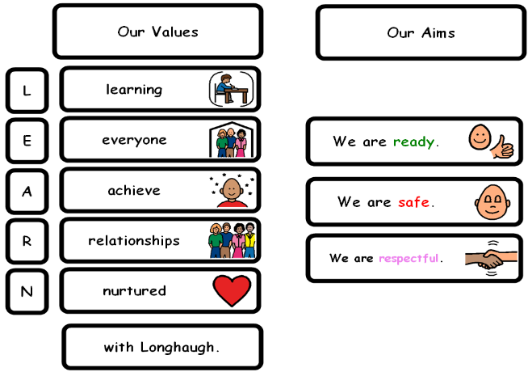

Our School’s Context:

Longhaugh Primary School serves the North East of the city of Dundee. We are part of a Scottish Attainment Challenge authority and approximately 48% of our pupils are entitled to free school meals. We received PEF allocation of £143, 000 for session 2021-22. The school is committed to removing barriers through our ‘Cost of the School Day’ action plan and our inclusive learning environment. Almost all pupils come to school ready to learn. We enjoy very strong support from all stakeholders in our local community especially from parents and partners.

Longhaugh Support Group (LSG) is also located within our setting, providing shared placements for a small number of pupils across Dundee. This specialist provision also offers an outreach service to schools, led by Mrs Melaine Kearns.

The priorities for the year’s action plan were grounded in the National Improvement Framework using key documents such as:

- Interventions for Equity diagram
- SAC: Learning & Teaching Toolkit
- HGIOS4
- Delivering Excellence and Equity in Scottish Education

Attainment Information
 | Year 1 |  |  |  | Year 4 |  |  |  | Year 7
 | R | W | L&T | N | R | W | L&T | N | R | W | L&T | N
2015/16 | 81% | 83% | 69% | 93% | 56% | 33% | 58% | 44% | 78% | 81% | 83% | 79%
2016/17 | 81% | 81% | 78% | 89% | 69% | 69% | 86% | 89% | 54% | 51% | 66% | 57%
2017/18 | 73% | 60% | 60% | 80% | 82% | 56% | 88% | 76% | 71% | 67% | 86% | 79%
2018/19 | 91% | 83% | 98% | 85% | 84% | 61% | 86% | 73% | 82% | 69% | 94% | 80%
2019/20  Predicted March | 80% | 78% | 88% | 85% | 69% | 48% | 71% | 67% | 82% | 70% | 82% | 82%
2020/21 | 83% | 70% |  | 83% | 89% | 70% |  | 81% | 88% | 76% |  | 82%

Attainment Data 2020-21
Year Group | Reading | Writing | Listening & Talking | Numeracy
P1 | 83% | 70% | 93% | 83%
P4 | 88% | 69% | 81% | 79%
P7 | 88% | 76% | 91% | 82%

Continuous Professional Development:
Over the past year, our staff members have undertaken a wide range of training and development, including:

- Moderation activities led by our school QAMSOs. Improved focus on moderation cycle to support planning. Moderation activities included in school collegiate calendar and are a key feature of all INSET days. These events are largely supported by DCC pedagogy team.

- QAMSOs attended local network meetings, sharing training and guidance with staff. Staff worked with Dundee pedagogy team to develop approaches to moderation.

- As part of our learn to read programme staff engaged with Ruth Miskin Portal, Oxford Owl, Literacy Shed, Clicker and Lexia. This training and resources supported our strong emphasis on raising attainment for all.

- All staff participated in our whole school writing project. This focused on ‘Tools for Writing & ‘Explicitly Teaching Writing’.

- Clicker 8 continues to be used well in some stages to engage reluctant writers. Staff who have engaged with this, offer support to staff who are unfamiliar with this programme. This will be developed further next school session.

- Staff regularly engage with improvement methodology. A targeted staff group participated in our first School Inquiry Group, Every Dundee Learner Matters (EDLM) with a focus on ‘Developing Number Talks’, a strategy to build accuracy and flexibility in mathematical thinking.

- Several staff engage with masters level study as part of their commitment to professional learning.

Review of Improvement Progress for Session 2021-22

School Improvement Priority 1:
Leadership & Management
Progress and Impact:

- Our Vision, Values and Aims are central to the culture, ethos and life of our school and have been agreed by our whole school community. We are currently refreshing our vision statement, this will be launched next session. These underpin all aspects of our work, with all staff encouraged to make references to these as part of daily learning & teaching episodes.

- We have reviewed our whole school relationships policy to ensure a consistent approach to supporting all learners in an inclusive environment for learning.

- We continue to use our online learning platform seesaw to offer extended learning/consolidation activities at home. This is used very well at some stages but does require a more consistent approach. This offer is a key tool to support children who may be absent from face-to-face learning in exceptional circumstances.

- We used creative ways to evaluate the work of the school through surveys, google forms, parent council and class council.

- We continue to engage with our action plan for Rights, Respecting School.

Next Steps:

- Develop our pupil understanding of the school values by raising the profile and having a termly focus.

- Continue to involve all stakeholders in self-evaluating the work of our school to identify key strengths and areas for development.

- Develop our engagement with improvement methodology as part of EDLM strategy. There will be three key priorities next session.

- Staff leaders to scale up our Number Talks School Inquiry Project.

- Continue to embed all aspects of our Relationships and Wellbeing policy, linking this with RRS approach. Produce an abbreviated version for parents and families.

School Improvement Priority:
Learning Provision

Progress and Impact:

- We provide a safe and inclusive learning environment for all learners.

- There is strong universal provision to meet the needs of learners. Some of our pupils are further supported through effective Able and Boxall planning.

- Staff continue to lead learning in a safe, happy, and structured way that enables children to be fully engaged in learning experiences. A consistent approach to sharing LIs and SC is evident across the school ensuring that pupils can talk confidently about what and how they are learning.

- Staff worked hard to engage pupils in learning through creative and motivating learning experiences. Staff engaged with ‘The Learning Cycle ‘. The structure of lessons improved which enabled our learners to be more involved in the learning episodes. Support with meta skills is at the early stages and will continue to be a focus next term.

- Our attainment in reading is good with a very consistent approach both in reading to learn and learning to read. A change in personnel has led to new staff taking on key leadership roles.

- All staff participated in our writing project which has started to improve teacher competency this session. Our literacy leader will develop this next session as we aim to see small gains in our data.

- The SIG Number Talks priority has been extremely successful and is reflected in pupil learning experiences and in the early data. This will be scaled up next session.

- Learning experiences are shared with families via our online platform seesaw. Some learners are confident at identifying aspects of learning independently.

- We offer many open doors events with different learning themes to share what and how children are learning.

Next Steps:

- To continue to develop our culture of reflective practice with all staff but also to create more opportunities for pupil voice and development of UNCRC.

- Continue to provide opportunities for staff to improve practice through our learning team approach. We aim to introduce video recording as part of our professional learning plan.

- Develop our digital learning strategy and upskill staff through in house and external support.

- Scale up writing project across all levels.

- All staff to engage with school improvement planning to prioritise key areas of improvement – EDLM inquiry groups.

- Develop our approaches to moderation including across the campus.

- Develop a more robust tracking system which highlights pupils requiring additional interventions.

- Review and refresh our standards for Literacy & Numeracy.

School Improvement Priority 3:

Our Success and Achievements Implement a staged approach to Health & Wellbeing (Nurturing Approach

Progress and Impact

- We are developing the role of a teaching staff member dedicated to nurture. This role offers responsive and targeted support to learners where appropriate. This role is also very effective in supporting staff where they have identified any pupils with barriers to learning. It has been a key factor in our recovery following the impact of lockdown.

- All ABLe plans have been reviewed and amended to be in line with the DCC new format. All Able plans shared with parents/carers during Team Around the Child (TATC) or organised meetings.

- We continue to have very strong partnerships with Health, DEPS, and the voluntary sector to effectively support wellbeing of pupils and families. The FORT referral system has improved how we access the most appropriate interventions.

- Our focus on our Relationships and Wellbeing policy and restorative practices have resulted in no exclusions recorded across the school year, increased engagement, and participation.

- We have improved how we measure children’s emotional and mental wellbeing using Glasgow resilience model. This is leading to a more targeted approach for our learners by class teachers. This information is also used to support children who have identified barriers to learning.

- We have developed a more robust system for supporting children and families in Team Around the Child process. A single database holds an overview of the process and identified smart targets for individuals and families.

Next Steps:

- Staff development around zones of regulation in our lower school classrooms so pupils can take more responsibility for self-regulation.

- Refresher in ABLE planning to address any barriers to pupil learning.

- Continue to offer professional learning opportunities to upskill staff to support mental wellbeing of pupils (Trauma Informed Practice).

- Develop how we include pupil voice within TATC process. Use wellbeing wheels with pupils to identify areas of concern and plan our smart targets.

- Familiarisation of refreshed GIRFEC guidance to ensure we are getting it right for every child/family in Longhaugh.

- Develop role of School & Family Development Worker (SFDW) in improving attendance and supporting families through cost-of-living challenges.

- To develop a system to track wider achievement.

- Using and implementing the new Dundee Standard for a Developmentally Appropriate Curriculum in P1 next session.

Our Improvement Priorities for Session 2022 and 2023

Leadership and Management

Promote our recently revised vision, values and aims within our school, community and beyond. Continue to embed our VVA into learning & teaching, encouraging our pupils to give their best version within all learning episodes.

All staff to receive training and awareness sessions on Trauma Informed Practice, in line with DCC implementation plan for trauma informed workforce.

Able refresher training to be delivered to all staff.

Learning Provision

Ensure provision of high-quality learning and teaching and learner engagement and participation for all
(Feedback; differentiation; learners leading learning)
All teaching staff to engage with EDLM strategy and participate in inquiry groups. Our focus will be in digital learning, meta skills and number talks.
Develop approaches to cross campus moderation.

Successes and Achievements
Have robust processes for use of data/analysis to monitor and track individual progress leading to improved outcomes (including attainment, achievement, attendance, exclusions) in line with our clearly defined improvement focus,’ Every Dundee Learner Matters.

Please visit www.careinspectorate.com or https://education.gov.scot/what-we-do/inspection-and-review/reports for Care Inspectorate or HMIE Inspection Reports.

Further Information can be found at:

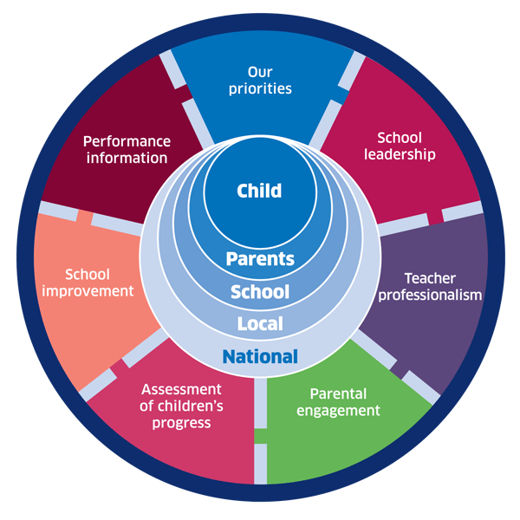 | 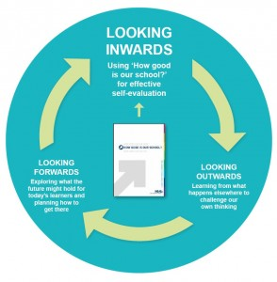 |  |   Dundee Education Plan  https://www.dundeecity.gov.uk/sites/default/files/publications/annual_education_plan_2017-18.pdf
National Improvement Framework  http://www.gov.scot/Publications/2016/01/8314 | HGIOS 4 Self-evaluation https://education.gov.scot/improvement/Documents/Frameworks_SelfEvaluation/FRWK2_NIHeditHGIOS/FRWK2_HGIOS4.pdf | Tayside Plan C&FS  External Link ' Tayside_Plan 1a.pdf'

