Longhaugh Primary School

LEARN with Longhaugh

LEARN | EVERYONE | ACHIEVE | RELATIONSHIPS | NURTURE

School Improvement Report
Session 2022-23


Longhaugh Primary School
Lothian Crescent
Dundee. DD4 0SX
Tel 01382 438540
Email: longhaughprimary@dundeeschools.scot

Our Vision

Together we ensure every learner matters equally.

Together we aim to provide a high quality, inclusive learning experience.

Together we promote lifelong learning opportunities for all.

Together we build strong, positive, and lasting relationships.

Together we show kindness.

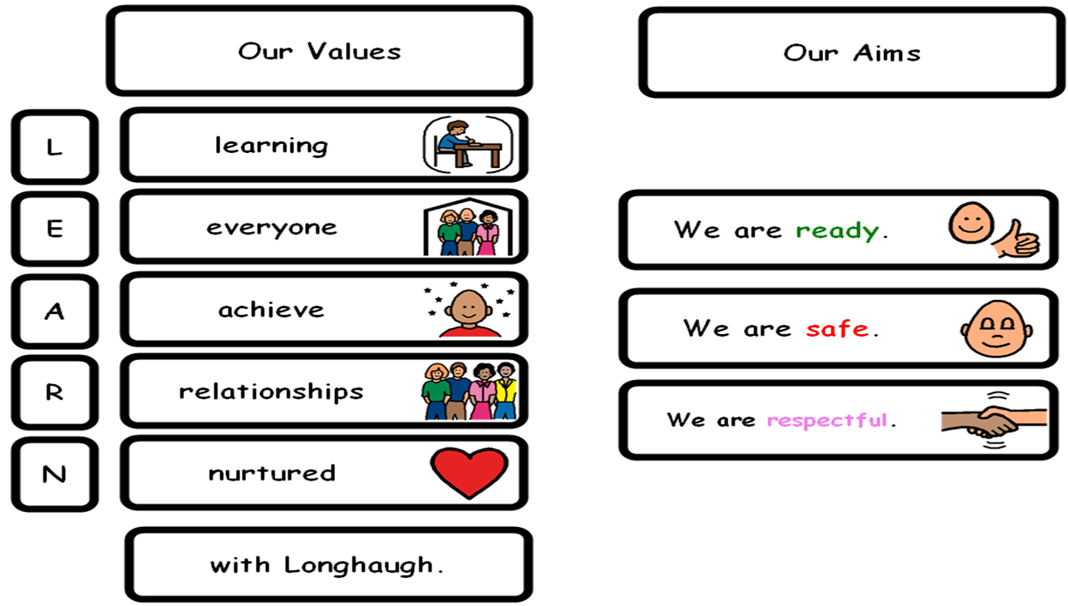

This document shares and celebrates the improvements in our school during session 2022-23. It is based upon our School Improvement Plan and additional improvements throughout the past year.

Our School’s Context:
Longhaugh Primary School serves the Northeast of the city of Dundee. We are part of a Scottish Attainment Challenge authority and approximately 57% of our pupils are entitled to free school meals. We received Pupil Equity Funding (PEF) of £143,325 for session 2022-23.

The school’s vision, values and aims are embedded in the daily life of the school and provide a common purpose to everyone in our school and community. Staff provide a caring and nurturing environment for children to learn.
Our focus on ready, safe, and respectful and our core values are the foundation of very strong and lasting relationships.

We are committed to removing barriers to learning through our inclusive learning environment where school staff work hard to adapt to the needs of our learners.

The school is non-denominational and has a total roll in June 2023 of 276. Longhaugh Support Group is a specialist provision within our school and is led by Mrs Melaine Kearns DHT, who also has a citywide remit supporting learners with social, emotional, and behavioural challenges.

We share the North East Campus with St. Francis RC Primary and Quarryview Nursery. The building opened in August 2018 offering a modern, spectacular place to learn. Our pupils are arranged across 12 classes.

Children come to school ready and eager to learn, demonstrating a strong Longhaugh identity. We welcome very positive support from all stakeholders in our local community. especially parents and partners. Whilst our parent council group is a small network of parents, they are proactive in supporting all aspects of school life. Last session the group sourced funding to support Christmas activities and were fundamental in sharing key safety messages regarding our new safer street’s initiative.
Our staff team are mixed in experience, but are committed to their roles, this includes all teaching, support, and admin staff, as well as the Senior Leadership Team. Staff are encouraged and supported to be lifelong learners with several staff completing additional Post Graduate training and masters level study.
All staff prioritise career long professional learning and work in collaboration to support and inspire one another. Our model of staff learning teams enable staff to work together, sharing skillsets to provide high quality learning experiences.

We are a bronze ‘Rights Respecting School’ working towards achieving silver accreditation. Our learners are beginning to demonstrate their understanding of rights and responsibilities. The launch of the silver plan was a successful school event with children enjoying a range of outdoor play resources to celebrate Article 31 ‘I have a right to relax and play’ and Article 42’ Everyone should know about the UNCRC.’
We strive to work in partnership with our pupils, families, colleagues, and wider partners. There is a collaborative inquiry approach to drive improvement in line with the local authority ‘Every Dundee Learner Matters’ strategy. We have very high expectations and aspirations for all our learners: every child is supported to succeed.

Attainment Data 2022/23
Year Group | Reading | Writing | Listening & Talking | Numeracy
P1 | 85% | 79% | 96% | 92%
P4 | 71% | 74% | 88% | 82%
P7 | 83% | 79% | 88% | 81%
The priorities for the year’s action plan were grounded in the National Improvement Framework using key documents such as:
- Interventions for Equity.
- Delivering Excellence and Equity in Scottish Education.
- Pupil Equity Fund: national operational guidance.
- SAC: Self-evaluation resource
- HGIOS4

Continuous Professional Development:
Over the past year, our staff members have undertaken a wide range of training and development activities, including:

- Moderation activities led by our school and campus QAMSO. Improved focus on moderation cycle to support planning for learning, teaching & assessment. Moderation activity is included in the school collegiate calendar and is a feature of all INSET days. These events are at times supported by Dundee City Council pedagogy team. This session we engaged with our campus colleagues to extend our moderation activity. Staff are collaborating effectively to make improved judgements on Curriculum for excellence levels.

- Our QAMSO attended local network meetings, sharing training and guidance with all staff. Moderation activity has become an integral part of our practice. Staff regularly discuss pupil progress and evidence of learning as part of their team meetings.

- Our staff team have engaged with sessions on Inquiry Based Learning, linking with the 3Ps of EDLM (Presence, Participation and Progress). All teaching staff are part of improvement methodology and inquiry-based learning groups to bring about improvement and change.

- Our 3 inquiry groups successfully led school priorities in the following areas:
- To scale up Number Talks across the whole school through developing and extending our approaches in all classes.
- Developing the use of digital technology to enhance learning, with a focus on seesaw lessons both in school and at home. Clicker 8 was also a pilot to engage reluctant writers and target identified pupils who were behind expected levels in writing from target year groups.
- To develop metacognition skills. The focus was to guide learners to become confident talking about their learning using appropriate vocabulary.

- Several staff continue to engage with Masters level study including inclusion, mental wellbeing and play based learning in the early years.

- Early years staff engaged with speech and language therapy partners to improve vocabulary across P1 & 2. They attended training in wordaware and delivered this in partnership with health throughout the school session.

Review of Improvement Progress for Session 2022-23

School Improvement Priority 1:
Leadership & Management
Progress and Impact:
- Following a period of consultation our refreshed school vision is now in place. As pupils become more familiar, an abbreviated version of our relationships policy will be shared with parents and partners. Our termly values focus has been very successful, with pupils able to discuss and demonstrate a better understanding of their meaning and how these can be modelled in school and beyond.
- All stakeholders have contributed to evaluating the work of the school to identify key strengths and areas for development. Parent feedback during school learning events will help inform plans for next session. Pupil voice and class council continue to give our learners an important voice in school life.
- All staff have engaged with improvement methodology as part of EDLM strategy. Our inquiry groups focused on digital learning, metacognition, and number talks. The three main drivers are PRESENCE, PARTICIPATION and PROGRESS.
- Staff judgement in assessing progress in CFE levels has improved. Additional assessment records and moderation activity have added strength to teacher judgement and provided robust supporting evidence. SNSA data is also used as a diagnostic tool to target interventions.
- Almost all staff have additional leadership responsibilities across the school.
- We have successfully introduced a co-teaching approach in some classes to improve teacher confidence in writing and team teaching reading skills. We hope to extend this model through pupil equity funding.
- Staff lead in house professional learning sessions. These have focused on aspects of literacy, numeracy, learner agency and enhancing learning & teaching using digital technology.
- Staff curriculum leads launched our skills academy programme involving all staff, some parent helpers, and partners. Pupils can apply for a range of activities including sewing, cooking, football, rugby, dance, and woodwork.
- Pupils take on different leadership roles including our P7 young workforce leads. There are also many opportunities within class to lead learning or take responsibility within the classroom environment.

Next Steps:
- Our vision, values and aims are embedded and modelled across the school. They will be strengthened next session as we continue our termly values focus and linked recognition awards.
- Develop our approaches to UNCRC and achievement of the silver award. Pupil leaders will be fundamental in this journey.
- The School Improvement Plan will continue to provide a clear direction and focus for improvement. Staff will continue to lead change through inquiry projects as part of the EDLM strategy. Time is allocated within the working time agreement to develop priorities.
- Continue embedding our moderation activity in school, across campus and within the cluster.
- Professional learning opportunities and PRD meetings to be used effectively to promote staff development.
- Develop our approaches to improving positive pupil attendance.

School Improvement Priority: Learning Provision to Health & Wellbeing (Nurturing Approach)

Progress and Impact:
- Almost all staff engaged with video recording to analyse their own practice, evaluate learning and teaching episodes. This model created opportunities for shared observations.
- There have been more opportunities for pupil voice and learner agency in the classroom. Pupils are involved in co-constructing success criteria, leading to increased participation in learning.
- Lessons are well planned and engaging using a variety of resources and interactive teaching methods to engage learners.
- We have continued to provide opportunities for staff to improve practice through our learning team approach. Staff engaged with the revised GTCS standards.
- We have developed our digital learning strategy and are upskilling staff through in house and external support.
- The writing project has been scaled up across all levels. Improvements in tools for writing is evident across all stages.
- Number Talks are now fully embedded in our practice and feature in our Numeracy Standard.
- Progression frameworks inform planning and ensure progression for learners across all stages.
- Targeted interventions and individual tutoring have been used effectively to support children and accelerate progress for some learners.
- Additional teaching time and best use of teaching assistant hours have been allocated to support closing the gap through Pupil Equity Fund (PEF).
- Word aware and talk for writing has had a positive impact on pupil Literacy skills in P1 & 2.
Next Steps:

- Develop our learning environment with a focus on a positive and nurturing place to learn. Staff will engage with Daniel Sobel and Sara Alston ‘ The Inclusive Classroom – A new approach to differentiation’.
- Continue working towards our silver Rights Respecting School award. This achievement will demonstrate our commitment to promoting children’s rights.
- Continue to develop our team planning approach to ensure high quality learning & teaching across all levels, improving teacher competency.
- Develop learner agency and the role of the learner within all learning episodes. Children should be leading learning at all levels. There will be a focus on meta skills.
- Develop our pedagogical approaches to reach predicted CfE levels creating a range of experiences including digital and outdoor learning.
- As a staff team and across campus we will continue to moderate learning, teaching and assessment to ensure progression in learning and confident teacher judgements of CfE levels.

School Improvement Priority 3: Successes and Achievementsstageoach to Health & Wellbeing (Nurturing Approach)

Progress and Impact

- We continue to prioritise pupil wellbeing, equity, and inclusion. We have a very inclusive and nurturing approach with positive relationships, mutual trust and respect embedded in our ethos and culture.
- Staff participated in training around zones of regulation. This is a feature in all lower school classrooms as part of our trauma aware environment. This approach supports learners to take responsibility for regulating their own emotions.
- All staff engaged with trauma informed training modules.
- Teaching staff engaged with and ABLE refresher to address any barriers to pupil learning. This resulted in all classes developing a universal ABLE plan to improve how children access learning, There has been a reduction in individual ABLe plans.
- At all levels, additional support needs are addressed very well through consultation, staff collaboration and multi-agency working. Our newly developed role of dyslexia co- ordinator is leading to better identification of Literacy difficulties.
- We have developed how we include pupil voice within Team Around the Child process. We make good use of the wellbeing wheels and data from the Glasgow wellbeing profiles to identify areas of concern which can be targeted in class or on an individual basis.
- Familiarisation of refreshed GIRFEC guidance to ensure we are getting it right for every child/family in Longhaugh.
- We have developed role of School & Family Development Worker in improving attendance and supporting families through cost-of-living challenges.

Next Steps:
- Develop SCARF programme into whole school assemblies.
- Continue to develop how we include pupil voice within Team Around the Child process. Use wellbeing wheels with all pupils to identify wellbeing concerns,
- Continue to develop our approaches to improving attendance as part of a cluster wide initiative.
- Extend our extra- curricular offer through the introduction of an active schools assistant, funded through PEF.
- Develop how we track attainment through robust data analysis. This should extend to additional curricular areas.

Our Improvement Priorities for Session 2023 and 2024

1.To review and develop our curriculum, placing the needs of our learners at the centre.

PARTICIPATION
2. Develop metacognition teaching strategies around knowledge, regulation, and motivation.
PROGRESS

3. To improve attendance
PRESENCE

Please visit https://education.gov.scot/what-we-do/inspection-and-review/reports for HMIE Inspection Reports.

Further Information can be found at:

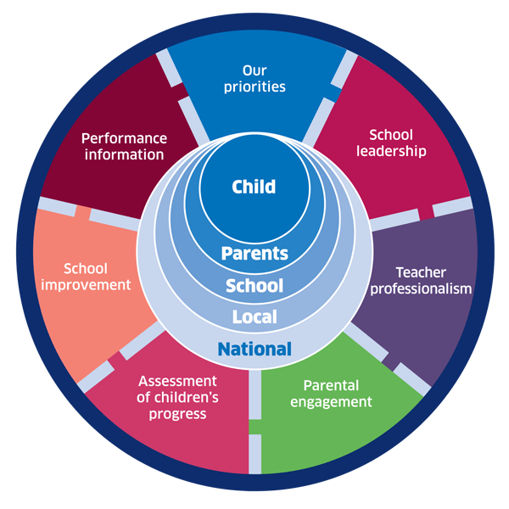 | 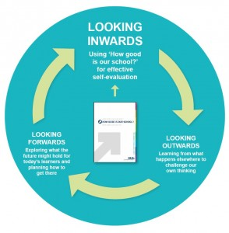 |  |   Dundee Education Plan  https://www.dundeecity.gov.uk/sites/default/files/publications/annual_education_plan_2017-18.pdf
National Improvement Framework  http://www.gov.scot/Publications/2016/01/8314 | HGIOS 4 Self-evaluation https://education.gov.scot/improvement/Documents/Frameworks_SelfEvaluation/FRWK2_NIHeditHGIOS/FRWK2_HGIOS4.pdf | Tayside Plan C&FS  External Link ' Tayside_Plan 1a.pdf'

